HALOKAZI
STAGE 4: SYSTEM ANALYSIS / BUSINESS ANALYSIS
Project Name | Halokazi
Document Title | Actor List & TO-BE Process Flows
SDLC Stage | Stage 4 of 14 — Hybrid SDLC (System Analysis / Business Analysis)
Methodology | Waterfall + Agile Scrum
Document Version | 1.1
Status | Draft — Pending Review
Prepared By | Raymond Avitus Gingi
Date | September 28, 2026

1. Purpose
This document consolidates the Stage 4 (System Analysis / Business Analysis) deliverables for Halokazi: the platform's Actor List and its TO-BE Process Flows. Together they describe who interacts with the system and how the platform's core cross-functional processes will operate once implemented, providing the foundation that Stage 5 (System Modeling) will use to construct Use Case Diagrams, ERD and other UML artifacts. In line with the project methodology, this document remains at a high level; detailed User Stories and Acceptance Criteria are produced later, at Stage 9

2. Actor List
2.1 Primary Actors
Primary actors are the human users who initiate and directly carry out the platform's core workflows.
Actor | Description | Key Goals
Job Seeker | An individual searching for employment, a recent graduate, an experienced professional, or anyone looking for a new opportunity or career advancement. | Build a professional CV, discover relevant vacancies, submit and track applications, receive alerts for new matching jobs.
Employer / Recruiter | A company, public organization, recruitment agency, or HR department that publishes vacancies and manages the recruitment process. | Publish and manage job postings, receive and review applications, communicate with and manage applicants.
System Administrator | An internal Halokazi staff member with elevated privileges responsible for platform management and oversight. | Maintain content quality, prevent and manage misuse, monitor platform health, generate administrative reports, verify employer documents.
2.2 Secondary Actors
Secondary actors are external systems and service providers that support Halokazi's functions but are not direct human users of the platform.
Actor | Role
SMS Gateway | Sends one-time passwords (OTPs) for account verification and delivers SMS-based notifications.
Notification Service | Sends application-status alerts, and job-matching in app notifications.
Cloud File Storage | Stores uploaded files such as CV documents, profile attachments, employer legal documents, and company logos.

3. TO-BE Process Flows
The two cross-functional diagrams below model the platform's core end-to-end processes in their intended future ('TO-BE') state. Each diagram groups activities into lanes by actor (Job Seeker, System, Employer, Admin) and into stages representing the major phases of the process.
3.1 Process 1: Job Application Management (Job Seeker – System – Employer)
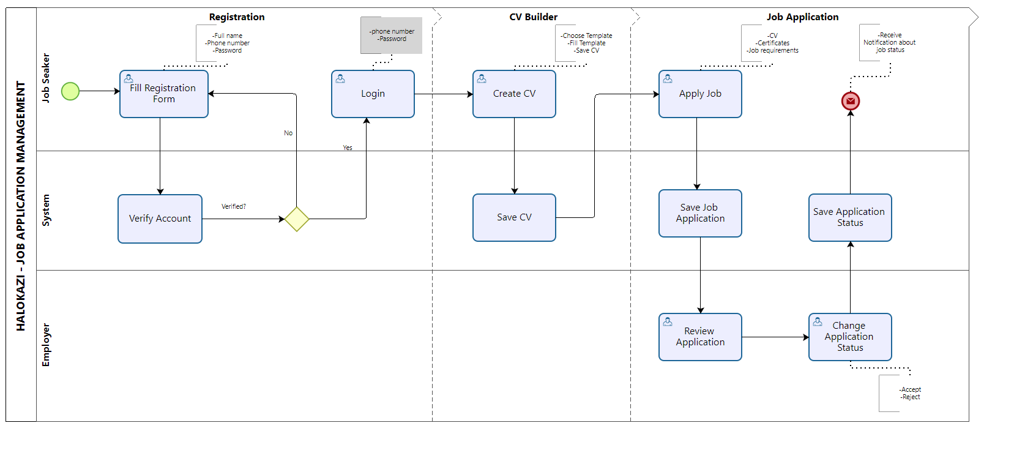
Figure 1. TO-BE: Registration, CV Builder and Job Application (Job Seeker-initiated).
This process describes the complete journey a job seeker follows on Halokazi: creating an account, building a CV, and submitting a job application through to receiving a decision. It runs across three lanes : Job Seeker, System and Employer and three stages: Registration, CV Builder and Job Application.
- Registration: The job seeker fills the registration form (full name, phone number, password). The System verifies the submitted details. If verification fails, the job seeker is returned to the registration form to correct and resubmit; if it succeeds, the job seeker proceeds to log in using their phone number and password.
- CV Builder: Once logged in, the job seeker creates a CV by choosing a template, filling it in, and saving it. The System stores the completed CV for later use.
- Job Application: The job seeker applies for a job, submitting their CV, certificates, and confirming they meet the job requirements. The System records the application and forwards it to the employer, who reviews it and sets a decision: Accept or Reject. The System saves this status and automatically notifies the job seeker, which ends the process.
Business Rules — Process 1
- A job seeker account must pass System verification before login is permitted; failed verification routes back to the registration form rather than to an error page.
- A saved CV and an authenticated session are both prerequisites for submitting a job application — a job seeker cannot apply without first registering, verifying, and building a CV.
- Every job application must carry a CV; certificates and confirmation against job requirements are additional expected inputs at the point of applying.
- Every employer decision (Accept/Reject) must be persisted by the System and automatically triggers a notification to the job seeker — no separate manual notification step exists in this flow.
3.2 Process 2: Employer Registration & Job Posting (Employer – System – Admin)
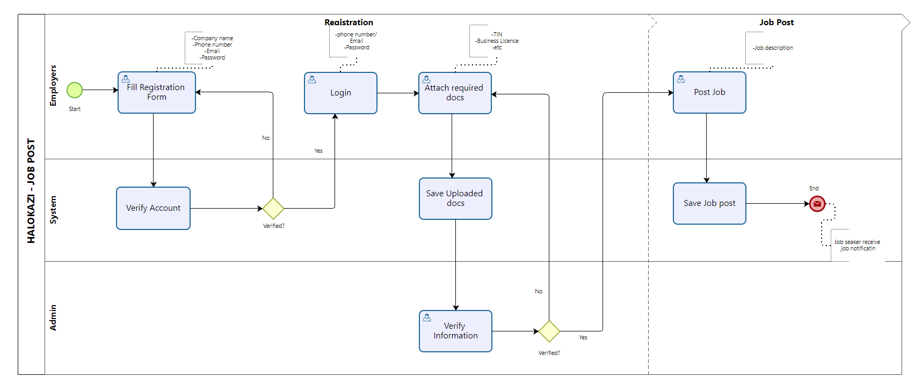
Figure 2. TO-BE: Registration (with Admin document verification) and Job Post (Employer-initiated).
This process shows how a company account is created, verified, and used to publish a vacancy. It runs across three lanes: Employers, System and Admin and two stages : Registration and Job Post. Unlike job seeker registration, employer registration includes a second, manual verification layer carried out by an Administrator before the employer may publish jobs.
- Registration: The employer fills a company registration form (company name, phone number, email, password). The System verifies these details, looping back to the form on failure, exactly as in Process 1. Once verified, the employer logs in and attaches required legal documents: TIN, Business Licence, and any other required files. The System saves the uploaded documents, and an Administrator reviews and verifies them. If the Admin rejects the documents, the employer is sent back to re-attach documents (not back to registration); once approved, the employer proceeds to the Job Post stage.
- Job Post: The employer posts a job by providing a job description. The System saves the posting and makes it available to job seekers, who receive a notification that a new job has been posted.
Business Rules — Process 2
- Employer verification is a two-step process: (1) automated account verification by the System, matching job seeker registration, and (2) manual document verification by an Administrator (TIN, Business Licence, etc.). Both steps must pass before an employer can post jobs.
- An employer cannot publish a vacancy until an Administrator has reviewed and approved the company's supporting legal documents — this directly implements the 'Fake Employer Accounts' risk control identified in the Stage 1 Project Initiation document (Risk 16.2).
- A rejected document submission returns the employer to the document-attachment step only, not to registration — previously verified account credentials remain valid.
- Once a job posting is saved by the System, notifying job seekers is an automatic system action, not a manual employer or admin task.
3.3 How the Two Processes Connect
The two processes meet at a single hand-off point: the “Post Job” / “Save Job Posting” activity at the end of Process 2 is what populates the job listings that job seekers search, filter and apply to at the start of the Job Application stage in Process 1. In other words, Process 2 is the upstream source of the vacancies that Process 1 consumes — a job cannot appear in a job seeker's search results until it has passed through employer registration, Admin document verification, and job posting.

